

CyberShield 360: Design and Analysis of an AI- Enabled Enterprise Cybersecurity Platform
CASE STUDY ANALYSIS REPORT

Submitted in the partial fulfilment for the Course of

CSA1012 – Software Engineering

to the award of the degree of

BACHELOR OF TECHNOLOGY

Submitted by
P.Sai Surya Tej (192572044)

UNDER THE SUPERVISION OF
Dr. K. Anita Davamani

SIMATS ENGINEERING
Saveetha Institute of Medical and Technical Sciences
Chennai-602105
July-2026
ACKNOWLEDGEMENT

We would like to express our heartfelt gratitude to all those who supported and guided us throughout the successful completion of our Capstone Project. We are deeply thankful to our respected Founder and Chancellor, Dr. N.M. Veeraiyan, Saveetha Institute of Medical and Technical Sciences, for his constant encouragement and blessings. We also express our sincere thanks to our Pro-Chancellor, Dr. Deepak Nallaswamy Veeraiyan, and our Vice-Chancellor, Dr. S. Suresh Kumar, for their visionary leadership and moral support during the course of this project.

We are truly grateful to our Director, Dr. Ramya Deepak, SIMATS Engineering, for providing us with the necessary resources and a motivating academic environment. Our special thanks to our Principal, Dr. B. Ramesh for granting us access to the institute’s facilities and encouraging us throughout the process. We sincerely thank our Head of the Department, Dr K. Anita Davamani for his continuous support, valuable guidance, and constant motivation.

We are especially indebted to our guide Dr K. Anita Davamani for his creative suggestions, consistent feedback, and unwavering support during each stage of the project. We also express our gratitude to the Project Coordinators, Review Panel Members (Internal and External), and the entire faculty team for their constructive feedback and valuable inputs that helped improve the quality of our work. Finally, we thank all faculty members, lab technicians, our parents, and friends for their continuous encouragement and support.

Signature With Student Name
P. Sai Surya Tej (192572044)

Abstract

The rapid growth of digital transformation, cloud computing, and interconnected enterprise systems has significantly increased the complexity and frequency of cyber threats. Traditional cybersecurity solutions, which primarily rely on signature-based detection and manual analysis, are no longer sufficient to identify sophisticated attacks such as ransomware, phishing, insider threats, Advanced Persistent Threats (APTs), and zero-day vulnerabilities. Enterprise Security Operations Centers (SOCs) face the challenge of analyzing massive volumes of security logs generated from networks, endpoints, cloud platforms, and applications, resulting in delayed incident detection, fragmented visibility, and slower response times.
This case study presents CyberShield 360, an AI-powered Enterprise Cybersecurity Monitoring and Threat Intelligence System designed to enhance organizational security through intelligent automation and real-time threat detection. The proposed platform integrates Artificial Intelligence (AI), Machine Learning (ML), behavioral analytics, and global threat intelligence feeds to continuously monitor enterprise infrastructure, detect anomalous activities, predict potential cyber threats, and automate incident response. By correlating security events from multiple sources, the system minimizes false positives, improves threat visibility, and enables proactive security management.
The proposed solution follows software engineering principles such as modularity, scalability, maintainability, reliability, usability, and security to ensure the development of a robust and enterprise-ready cybersecurity platform. An Agile Scrum development methodology integrated with DevSecOps practices is recommended to support continuous development, rapid deployment, and evolving security requirements. The platform includes modules for data collection, AI-based threat detection, threat intelligence integration, automated response, compliance management, and interactive security dashboards.
The expected outcomes of CyberShield 360 include faster threat detection, reduced incident response time, improved regulatory compliance, enhanced protection against advanced cyberattacks, and greater operational efficiency for security teams. Although challenges such as implementation cost, AI model maintenance, legacy system integration, and privacy concerns remain, the proposed platform provides a scalable and intelligent approach to strengthening enterprise cybersecurity. Overall, CyberShield 360 demonstrates how AI-driven technologies and software engineering practices can be combined to build a modern, resilient, and proactive cybersecurity solution capable of addressing the evolving threat landscape.

CyberShield 360: Design and Analysis of an AI-Enabled Enterprise Cybersecurity Platform
Course: Software Engineering and Information Security | Document Type: Comprehensive Case Study Report | Case Study: CyberShield 360 Enterprise Cybersecurity Platform

Table of Contents
- 1. Introduction
- 2. Executive Summary
- 3. Problem Understanding
- 4. Stakeholder Analysis and Challenges
- 5. Current System Analysis
- 6. Proposed CyberShield 360 Solution
- 7. SDLC / Methodology Justification
- 8. Expected Outcomes, Risks, and Limitations
- 9. Conclusion

1. Introduction
Cybersecurity has become a foundational concern for contemporary enterprises operating in hybrid environments that span corporate data centers, public cloud platforms, remote endpoints, and third-party services. As digital transformation accelerates, organizations generate unprecedented volumes of security-relevant data and face increasingly sophisticated adversaries who exploit this complexity. In this context, traditional signature-based tools and isolated point solutions struggle to provide timely, end-to-end protection. CyberShield 360 is conceived as an AI-enabled, enterprise-grade cybersecurity platform that aims to address these challenges through unified monitoring, intelligent threat detection, and orchestrated incident response.
From a software engineering perspective, CyberShield 360 represents a complex socio-technical system that must reconcile heterogeneous technical requirements (e.g., scalability, reliability, and security) with organizational needs (e.g., governance, compliance, and analyst usability). This report adopts an academic case study lens to examine the platform’s design and analysis, with particular emphasis on problem framing, stakeholder perspectives, system requirements, and methodology selection.
- Focus: Design and analysis of an enterprise-grade, ML-enabled security monitoring and response platform for heterogeneous on‑premise and cloud infrastructures, positioned as a central hub for Security Operations Center (SOC) activities.
- Scope (in scope): Conceptual design of the CyberShield 360 platform, including problem definition, stakeholder and requirement mapping, high-level architecture, methodology justification, and qualitative assessment of expected outcomes, risks, and limitations.

2. Executive Summary
- Scope (out of scope): Low-level implementation details, exact algorithms and model parameters, quantitative evaluation metrics, and organization-specific deployment roadmaps are not specified, as the emphasis remains on conceptual design and academic analysis.
CyberShield 360 addresses the growing complexity and scale of cybersecurity threats faced by enterprises operating hybrid infrastructures. The current landscape is characterized by fragmented tools, delayed detection, and manual-intensive incident handling. This report argues that an integrated platform such as CyberShield 360, combining continuous monitoring, machine-learning-based detection, and automated workflows, can significantly improve threat visibility, response speed, and compliance assurance, provided that it is developed using a disciplined, security-focused software development life cycle (SDLC).

2. Executive Summary
This case study analyzes CyberShield 360, a proposed AI-driven cybersecurity platform intended to strengthen enterprise defenses against modern, large-scale, and evolving cyber threats. The central problem addressed is the inability of conventional, largely signature-based and siloed security tools to correlate heterogeneous logs, detect complex attack patterns, and coordinate timely incident response within hybrid infrastructures. Organizations face operational bottlenecks, incomplete visibility, and increasing regulatory pressure, all of which create a compelling need for a more integrated and intelligent security operations capability.
CyberShield 360 is proposed as a unified platform that aggregates telemetry from networks, endpoints, and cloud services; applies machine-learning-based analytics to identify anomalous behavior and known attack techniques; and provides orchestration mechanisms for automated and semi-automated incident response. The platform is positioned as the primary working interface for SOC analysts while simultaneously offering strategic oversight dashboards for executive management and structured evidence for compliance and audit stakeholders.
- Solution: CyberShield 360 as a unified monitoring, detection, and automated response platform aligned with functional and non-functional requirements.
From a methodological standpoint, the report justifies the use of an Agile Scrum–oriented SDLC enriched with security-by-design practices. This choice reflects the inherently dynamic nature of the cyber threat landscape and the need for continuous refinement of detection models, response playbooks, and integrations. In contrast, more rigid, linear methodologies such as Waterfall are argued to be less suitable for systems where requirements evolve rapidly in response to new vulnerabilities, attack vectors, and regulatory expectations.
- Methodology: An iterative, risk-driven SDLC (e.g., Agile with security-by-design practices) to accommodate evolving threats while maintaining compliance.
The expected impact of CyberShield 360 is multi-dimensional. Operationally, the platform aims to reduce alert fatigue, accelerate detection and containment, and standardize incident handling through codified workflows. Strategically, it promises improved visibility into organizational risk posture, more effective governance, and smoother compliance reporting. At the same time, the report acknowledges important limitations and risks, including dependence on high-quality data, potential model drift, integration complexity, and ethical and privacy considerations that must be addressed through careful design and governance.
- Outcomes: Improved incident detection and response, higher reliability and scalability, enhanced regulatory compliance, with acknowledged limitations around data quality, model drift, and organizational readiness.
- Problem: Organizations struggle to correlate high-volume, heterogeneous security telemetry and respond to sophisticated, multi-stage attacks in near real time using fragmented and largely rule-based tools.
- Stakeholders: Enterprise management (CISO and senior IT leaders), SOC analysts, IT administrators, compliance and audit officers, end users/employees, third‑party threat intelligence providers, and (where applicable) external customers who rely on the enterprise’s secure service delivery.
- Proposed solution: CyberShield 360 as a unified monitoring, detection, analytics, and incident‑orchestration platform, explicitly designed around both functional requirements (e.g., monitoring, detection, automation) and non‑functional requirements (e.g., scalability, reliability, security, usability, and maintainability).
- Methodology choice: Agile Scrum with embedded security-by-design activities and continuous stakeholder feedback, enabling iterative refinement of models, rules, and workflows in response to operational experience and evolving threats.
- Expected impact: Enhanced threat visibility, faster and more consistent incident response, better alignment with regulatory and governance requirements, and a more resilient overall security posture, subject to constraints related to data quality, organizational maturity, and ethical handling of security-relevant data.
- Operational bottlenecks: SOC analysts must manually inspect and prioritize large numbers of alerts, leading to delayed or missed incident responses.
- Compliance pressure: Organizations must maintain auditable records and demonstrate adherence to cybersecurity and data protection regulations.

4. Stakeholder Analysis and Challenges
CyberShield 360 intersects with a broad ecosystem of stakeholders whose roles, expectations, and constraints must be explicitly understood for the platform to deliver value. Beyond technical correctness, the success of the system depends on how well it supports day‑to‑day operational work, strategic decision‑making, and compliance obligations, while respecting the rights and responsibilities of employees and external parties.
Stakeholder | Role | Responsibility
Security Operations Center (SOC) | Primary Users | Monitor alerts, investigate incidents, and manage real-time response.
CISO / IT Management | Strategic Oversight | Define security strategy, manage risk, and ensure regulatory compliance.
System Administrators | Infrastructure Support | Maintain network/cloud resources and integrate system logs into the platform.
Regulatory Bodies | Compliance Auditors | Ensure the system adheres to legal and industry cybersecurity standards.
End Users / Employees | Data Producers | Adhere to security policies and report suspicious activities to the SOC.
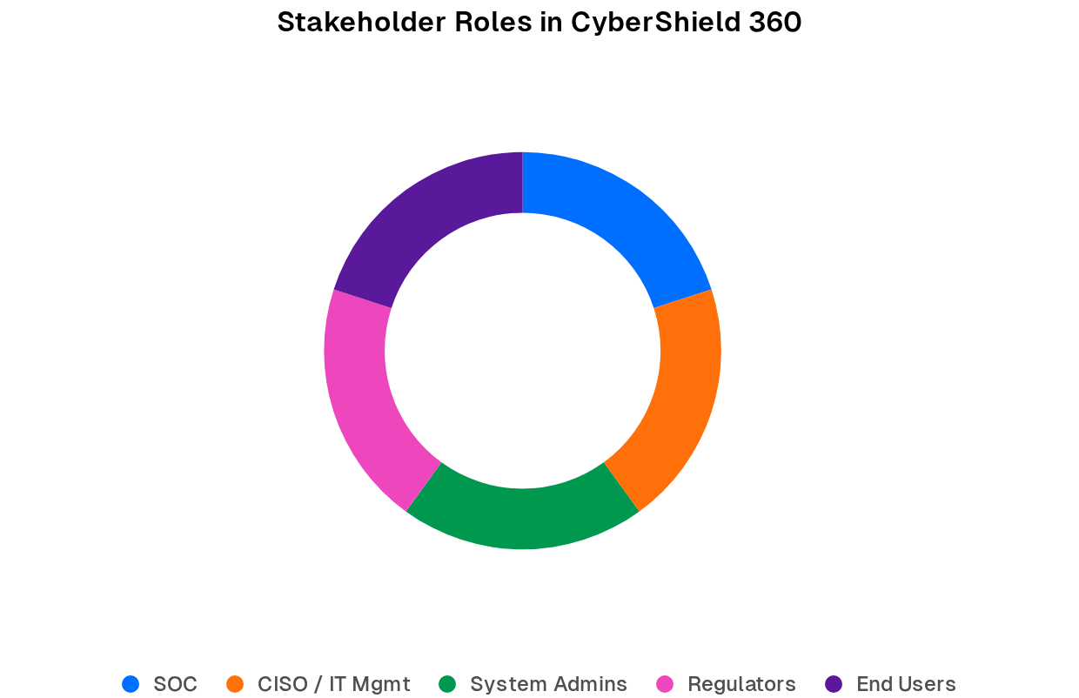
- Security Operations Center (SOC) analysts: Primary operational users who monitor dashboards, investigate alerts, conduct incident triage, and initiate or approve response actions. Their concerns include alert accuracy, usability of investigation workflows, reduction of manual tasks, and the ability to reconstruct incidents reliably.
- CISO and enterprise management: Senior leaders responsible for security strategy, risk appetite, and alignment with business objectives. They require aggregated metrics, trend analyses, and assurance that investments in CyberShield 360 translate into measurable improvements in risk reduction and regulatory compliance.
- IT and system administrators: Owners of underlying networks, servers, endpoints, and cloud resources who deploy agents, configure log forwarding, and manage integrations. Their priorities include minimal performance overhead, stable integrations, clear change procedures, and the ability to automate routine containment actions without compromising service availability.
- Compliance officers and internal/external auditors: Stakeholders who evaluate whether monitoring, logging, and incident response processes satisfy legal, regulatory, and internal policy requirements. They focus on audit trails, evidence retention, role-based access control, and the transparency of how security decisions are made and documented within the platform.
- End users / employees: Members of the organization whose everyday activities produce much of the security-relevant data. They are affected by security controls such as endpoint monitoring and email filtering, and their concerns include clarity of security policies, potential impacts on productivity, and the ethical handling of their personal or behavioral data.
- Third‑party threat intelligence providers: External entities that supply indicators of compromise, reputational data, or contextual threat information to enhance detection quality. Their integrations must be reliable, timely, and governed by appropriate contractual and security controls.

5. Current System Analysis
- Customers and business partners (where relevant): External parties who depend on the organization’s secure delivery of products and services. While they may not interact with CyberShield 360 directly, they are indirect beneficiaries whose trust can be affected by the platform’s effectiveness in preventing and managing incidents.
In many enterprises, the existing cybersecurity environment has grown organically over time and consists of multiple point solutions: endpoint antivirus, network firewalls, intrusion detection or prevention systems, cloud-native logging tools, and standalone Security Information and Event Management (SIEM) platforms. These tools often operate in isolation, are managed by different teams, and use distinct data models and interfaces. Although basic log aggregation may be in place, correlation is typically limited to static rules and dashboards that focus on individual technologies rather than end‑to‑end attack campaigns.
This fragmented architecture produces a range of systemic weaknesses. First, visibility is uneven: some endpoints or cloud accounts may be weakly monitored or not monitored at all, creating blind spots that attackers can exploit. Second, signature- and rule-based detections are inherently reactive and lag behind new attack techniques, which can lead to undetected intrusions. Third, incident handling relies heavily on manual processes in which analysts must pivot across tools, copy data between interfaces, and coordinate response activities through email or chat rather than structured workflows. Finally, generating consolidated compliance evidence requires extensive manual effort to extract and reconcile logs from multiple systems, increasing the likelihood of errors or omissions.
From a design perspective, the core limitation is that current solutions treat security monitoring and response as a collection of loosely coupled capabilities rather than as an integrated, end‑to‑end process. The absence of a unifying data and workflow layer hinders the use of advanced analytics, slows decision‑making, and complicates governance. CyberShield 360 is positioned to address precisely these gaps by providing a coherent platform that centralizes telemetry, embeds intelligence, and codifies response procedures.
- Tool fragmentation: Multiple point solutions with limited integration complicate incident reconstruction and forensic analysis.
- Limited intelligence: Rule-based systems struggle to detect subtle or novel threats that do not match predefined signatures.
- Manual workflows: Incident response often relies on ad hoc human procedures rather than codified, automated playbooks.
- Inefficient compliance reporting: Audits require data extraction from multiple systems, with limited centralized evidence of monitoring coverage and response actions.

6. Proposed CyberShield 360 Solution
CyberShield 360 is envisaged as an integrated security operations platform that unifies monitoring, detection, investigation, and response across the enterprise. Conceptually, the platform sits at the center of the organization’s security architecture, ingesting telemetry from networks, endpoints, identity and access management systems, cloud services, and external threat intelligence sources. It applies analytics and machine-learning models to this data to surface high‑risk events and sequences of behavior, and then orchestrates standardized response actions through configurable playbooks.
At a high level, the architecture can be described in layered terms: (1) a data collection and integration layer composed of agents, connectors, and APIs; (2) a scalable data processing and storage layer that normalizes, enriches, and persists logs and events; (3) an analytics and detection layer that combines rules, heuristics, and ML models to identify threats; (4) an orchestration and automation layer that encodes incident workflows and triggers responses across infrastructure; and (5) user experience layers tailored to SOC analysts, managers, and auditors. Cross‑cutting concerns such as security, privacy, reliability, and observability are embedded across all layers rather than treated as afterthoughts.

6.1 Functional Requirements Overview
The table below summarizes key functional and supporting non‑functional requirements for CyberShield 360, grounded in the previously identified stakeholder needs and current system gaps. These requirements collectively guide the architecture, data model, and interaction design of the platform.
Category | Requirement Description | Type
Monitoring | Continuous analysis of network traffic, endpoints, and cloud resources. | Functional
Detection | ML-based identification of malware, phishing, and ransomware. | Functional
Automation | Automated incident prioritization and response workflows. | Functional
Scalability | Ability to handle massive log volumes across diverse IT infrastructure. | Non-Functional
Reliability | 24/7 uptime for critical threat intelligence feeds and monitoring. | Non-Functional
Security | Encryption of stored logs and strict access control for administrators. | Non-Functional
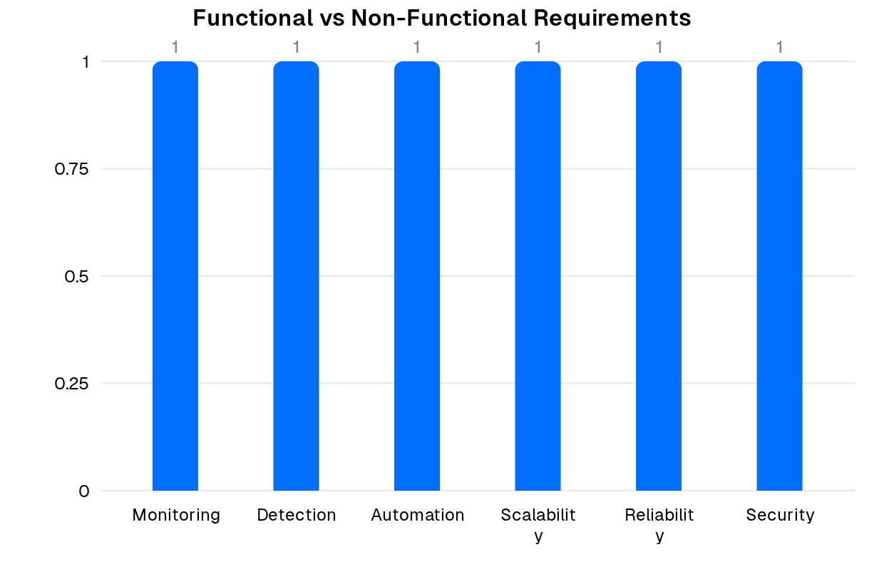
- Monitoring: The platform must provide continuous, unified visibility across networks, endpoints, identity systems, and cloud assets to minimize blind spots and support end‑to‑end incident reconstruction.
- Detection: Machine‑learning‑based and heuristic mechanisms should detect malware, phishing, ransomware, and anomalous behaviors that are not captured by static signatures alone, while allowing analysts to tune sensitivity.
- Automation and orchestration: The system should prioritize high‑risk incidents and orchestrate standardized response workflows (e.g., isolating hosts, disabling accounts, blocking IPs) with clear human‑in‑the‑loop approval where appropriate.
- Scalability and reliability: The platform should handle large and variable log volumes while maintaining predictable performance and high availability for critical monitoring and response functions.
- Security and privacy: Stored logs and configuration data must be protected through encryption, access control, and auditing, with careful handling of any personal or sensitive information embedded in security telemetry.

7. SDLC / Methodology Justification
Given the mission‑critical nature of cybersecurity and the rate at which threats, technologies, and regulatory expectations evolve, the development of CyberShield 360 is best supported by an iterative, feedback‑driven SDLC. Agile Scrum is particularly appropriate because it structures work into time‑boxed sprints, maintains a prioritized product backlog, and emphasizes continuous stakeholder collaboration. For CyberShield 360, this means that features such as new data connectors, refined ML models, or updated response playbooks can be delivered incrementally and validated quickly with SOC analysts and administrators.
Moreover, Agile practices can be augmented with explicit security‑by‑design activities: threat modeling during backlog refinement, secure coding standards enforced via code review and automated checks, and regular penetration testing of critical components. Continuous integration and continuous deployment (CI/CD) pipelines enable frequent, reliable releases while incorporating automated unit, integration, regression, and security tests. This combination of agility and rigor is well suited to a platform that must adapt continually without compromising stability or trustworthiness.
- Security-by-design: Threat modeling, secure coding standards, and periodic penetration testing integrated into the SDLC.
- Iterative delivery: Frequent releases of prioritized features allow rapid adaptation to new attack techniques and regulatory requirements.
- Stakeholder collaboration: SOC, CISO, and administrators are continuously involved in backlog refinement, sprint reviews, and user acceptance testing.
- Operational feedback loops: Production telemetry and incident post-mortems feed back into requirements and design decisions.

8. Expected Outcomes, Risks, and Limitations
If effectively designed and adopted, CyberShield 360 is expected to deliver improvements across several dimensions. Operationally, SOC teams should experience more coherent situational awareness, reduced effort in correlating events, and faster movement from detection to containment and recovery. Strategically, enterprise management can benefit from clearer visibility into security posture, trends over time, and the effectiveness of investments in controls. From a governance perspective, the platform can make it easier to demonstrate compliance through consolidated audit trails and standardized reporting.
At the same time, delivering these outcomes is contingent on mitigating a range of risks and limitations. The performance of ML‑based detection is sensitive to the quality, coverage, and representativeness of input data; inadequate data sources may lead to blind spots, while poorly tuned models can create noise through false positives. Integration with legacy systems and diverse cloud environments can be technically challenging and may introduce deployment delays or transitional vulnerabilities. Finally, organizational factors—including resistance to process change, limited security skills, and insufficient training—can significantly reduce the realized benefits of the platform.
- Expected benefits: Faster detection and containment of threats, reduced manual workload for SOC teams, improved consistency of incident handling, and more efficient, traceable compliance reporting.
- Technical risks and limitations: Potential model drift over time, integration challenges with heterogeneous and legacy systems, performance bottlenecks under peak load, and the need for robust monitoring of the platform itself.
- Organizational and process limitations: Dependence on sustained stakeholder buy‑in, adequate training for SOC and IT staff, clear governance of automated actions, and alignment with existing incident response and change‑management processes.
- Ethical and privacy considerations: Security telemetry can contain personal or sensitive information about employees and customers. The platform must therefore support data minimization, appropriate retention periods, role‑based access control, and transparency about monitoring practices, in line with relevant data protection principles.

9. Conclusion
The CyberShield 360 case study demonstrates how an AI‑enabled, integrated security operations platform can address the structural limitations of fragmented, signature‑centric cybersecurity tooling in modern enterprises. By grounding the design in a clear understanding of the problem space, a detailed stakeholder analysis, and explicit functional and non‑functional requirements, the proposed solution articulates a coherent pathway toward more effective monitoring, detection, and response across heterogeneous IT environments.
From a software engineering standpoint, the analysis underscores that technical innovation alone is insufficient. The choice of an Agile Scrum methodology, combined with security‑by‑design practices and strong stakeholder collaboration, is critical to ensuring that CyberShield 360 remains aligned with evolving threats, organizational workflows, and regulatory expectations. Equally important are the recognition and management of limitations related to data quality, system integration, organizational culture, and ethical handling of security‑relevant information.
Overall, CyberShield 360 can be viewed as a holistic socio‑technical system that integrates advanced analytics with human expertise, governance structures, and organizational processes. The case study contributes an assignment‑ready framework for systematically examining such platforms—moving from problem understanding and stakeholder analysis through to system design, methodology justification, and reflection on outcomes and constraints—thereby supporting both academic learning and practical reasoning about complex cybersecurity solutions.
- Future work: Further elaboration of detailed architecture, test strategies, and deployment roadmaps can extend this analysis into an implementation-ready design.

